Courageous Aging Book Data
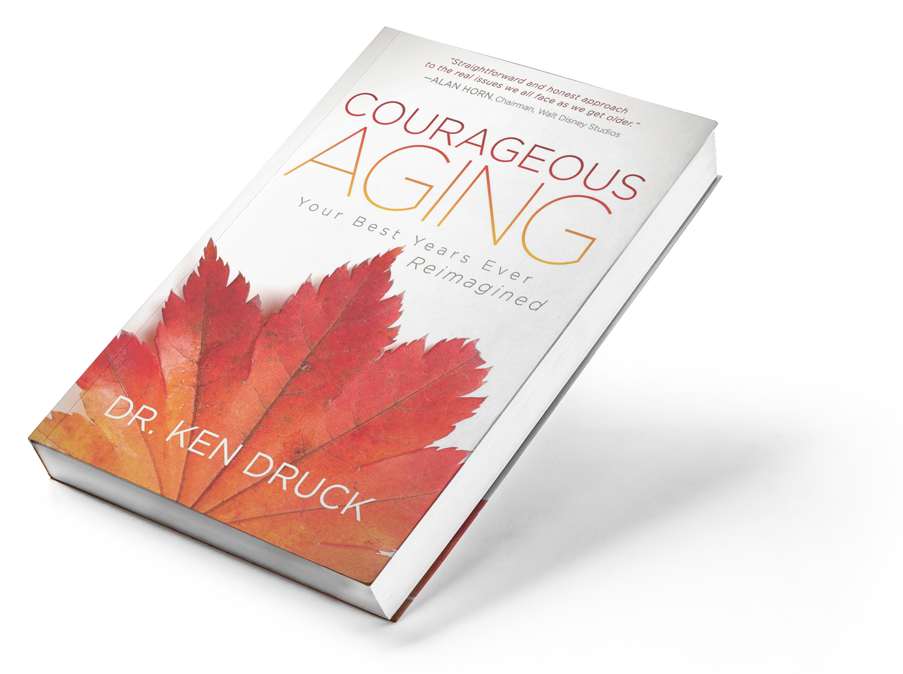
Title and subtitle Courageous Aging: Your Best Years Ever Reimagined
Author name Dr. Ken Druck
Publisher Morgan James Publishing
Publication date October 3, 2017
Page count 184
Category >Self-Help
>Health>Aging>Longevity
Price $17.95 print; $7.99 electronic
ISBN-10 1683504488
ISBN-13 978-1683504481
Format and binding Paperback
Description In Courageous Aging: Your Best Years Ever Reimagined, Dr. Ken Druck uses examples from his life and work to free readers of the destructive and limiting myths, biases, stereotypes, and misconceptions of getting older. Dr. Druck shows how all people can make peace with, and find joy in, every stage of life. His practical and inspirational approach speaks to anyone who wants to redefine what it means to age and embrace the transition of a new decade in one’s life.

